For More Information Contact
Jeff Fox
(703) 532-9343
jeff@commandav.com

Command Performance Debuts 4 New Products
At Capital Audiofest 2023

Command Performance AV will debut four exciting new products in the Democracy room at the Capital Audiofest.
Powering the system will be the North American premier of the Gryphon Audio Diablo 333 integrated amplifier. The Diablo 333 is the successor to Gryphon’s legendary Diablo 300, acknowledged to be among the finest Integrated Amplifiers ever built. Utilizing technologies and components developed for their State-of-the-Art Apex Power Amplifier, the 333 represents a significant step forward in both performance and functionality from Gryphon’s class-leading Diablo 300. Diablo 333 carries an MSRP of $24,990, with DAC and Phono Modules available separately.

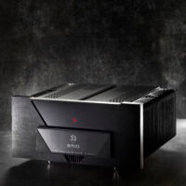

The analog source for this event will be the North American premier of the J.Sikora Standard MAX Special Edition turntable and using the new Aidas Mk.II Gold-Series Cartridge mounted on a J.Sikora KV MAX tonearm. The Special Edition Series makes available J.Sikora’s full line of award-winning turntables in custom colors. Customers can specify their color preference when placing a turntable order at any J.Sikora dealer. At the Capital Audiofest, a Standard MAX turntable will be shown in a stunning Metallic Ferrari Red. There is a 15% surcharge for the Special Edition of the turntables.

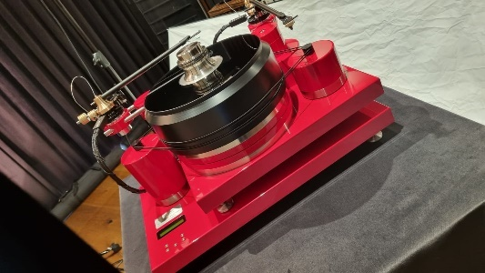

The Aidas Mk.II Gold series moving coil cartridges are the top performers in Aidas Cartridges portfolio. Each model in this series uses a unique body material, 24kt pure gold coils, a boron cantilever, a Microridge stylus, and an AlNiCo 5 magnet. The Aidas that will be used CAF has a body made out of certified 21,000-year-old Siberian Wooly Mammoth tusk. MSRP of this cartridge is $8,650.

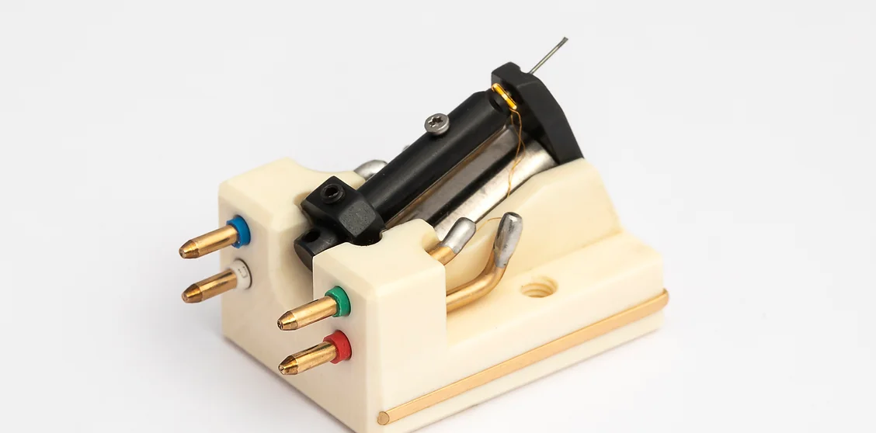

Making their East Coast show debut in the Democracy room will be the Magico S3-2023 speakers. The new S3 incorporates the knowledge distilled from and technological advances of the statement M9 speakers. Improvements have been made throughout the speaker, such as a 30% quieter newly engineered enclosure, Magico’s 28mm diamond-coated beryllium diaphragm tweeter, a 5-inch honeycomb aluminum core sandwiched midrange driver, and two 9” woofers employing an enhanced version of Magico’s Graphene Nano-Tec cone.
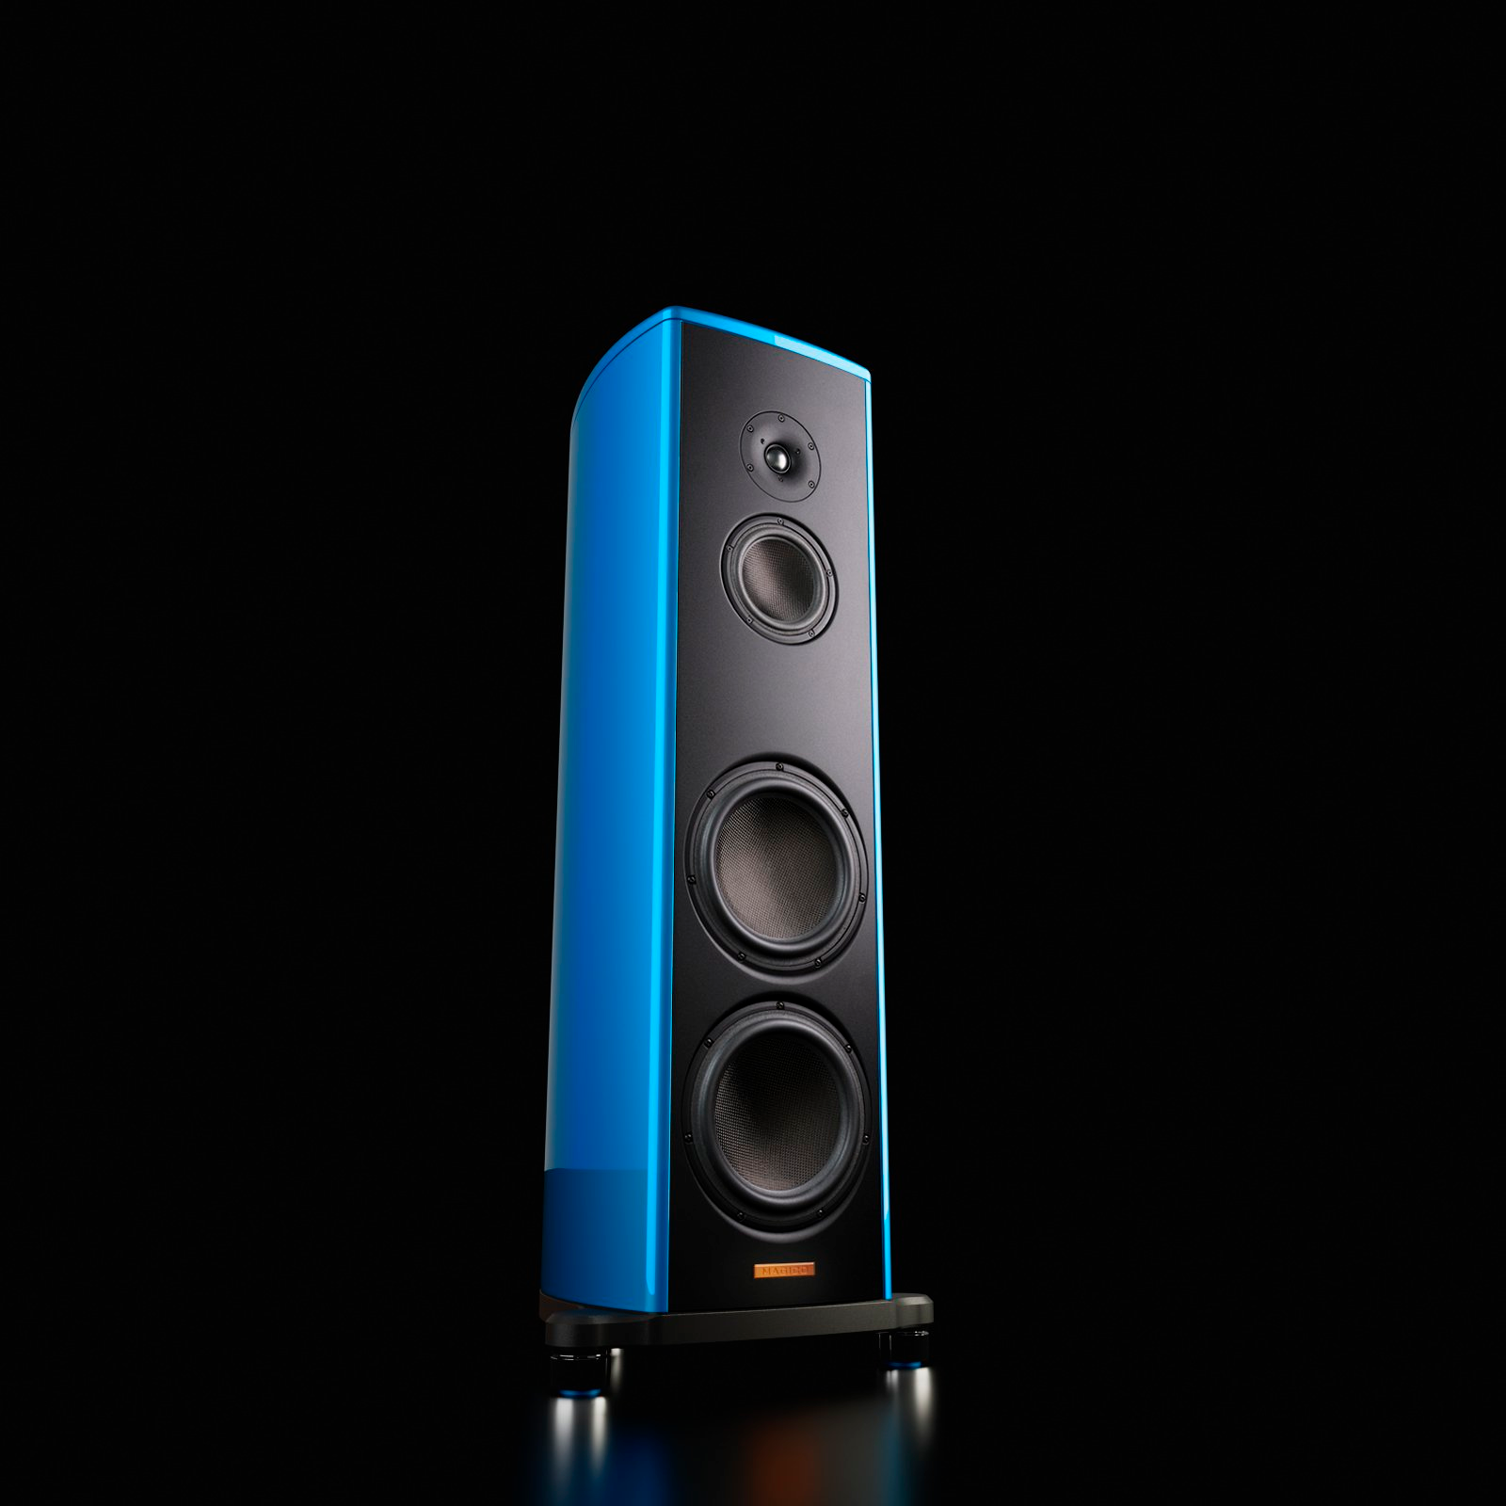

Completing the system will be the Aurender N30SA music server, Berkeley Alpha DAC Reference Series 3 and Alpha USB, Doshi Audio phono stage, and Transparent cables.
This exhibit promises extraordinary sonics, so please stop by for a listen, and to speak with the Command Performance team.
About Command Performance AV: Founded in 2007 by Jeff Fox, Command Performance is one of America’s premiere High End Audio Salons. Famous for their friendly, low-pressure service, Jeff and his team feature the world’s best products including Gryphon, J.Sikora, MSB, Innuos, HRS, Marten, Magico, DeVore Fidelity and many others. For more information, please contact Jeffrey Fox jeff@commandav.com

